Name: ___________________________________ Date: _______________

Approximately how long have you had this pain?__________________
Is this your first episode of this pain? ________ Yes _________ No
Is the pain- ______ Continuous or ______ Intermittent?
When is your pain worst? ___Morning ___ Daytime ___ Night ___ Random

Please mark on the following body diagram the location and type of pain you are currently having using the following letters:

N- Numbness S- Stabbing/ Sharp A- Ache
B- Burning P- Pins and Needles

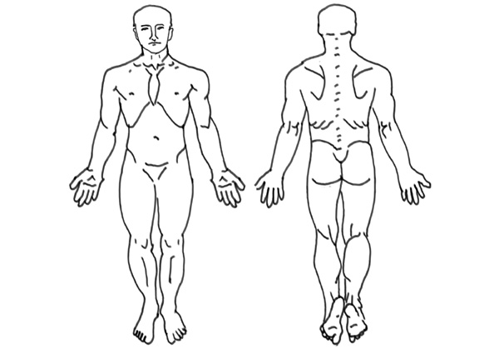

Please rate your current pain level by circling the appropriate number:

0 1 2 3 4 5 6 7 8 9 10

NO PAIN HIGHEST PAIN

